**USER MANUAL**

**Computer Science Project II – CS692**

**NEWS ASSISTANT**

**Team Members**

KINNARI JASOLIYA

CHANDNI SHAH

PRADEEP PRAKASH

GUANNAN ZOU

LONGYUAN CHU

Seidenberg School of Computer Science and Information Systems

Pace University, New York, NY, USA

Guided By: Prof. Henry Wong

Table of Contents

1.0 INTRODUCTION 3

1.1 System Overview 3

1.2 Users 3

1.3 Features 3

2.0 SYSTEM requirements 3

3.0 Functionalities 4

3.1 Home Page 4

3.2 Sign Up 4

3.3 Log In 5

3.3.1 Save Password 5

3.3.2 Forgot your Password 6

3.4 Landing Page 7

3.5 Categories 7

3.5.1 Sports 7

3.5.2 Entertainment 8

3.5.3 Technology 8

3.5.4 Fashion 9

3.6 Detailed News Article View 9

**USER MANUAL**

# 1.0 INTRODUCTION

## 1.1 System Overview

This User Manual provides the information regarding usage of our chat-based News Assistant website. We aim to create a Chat-based news assistant that will provide different categories of news and recommendations based on the user’s interests, while not distracting users with endless notifications on web/smartphones. There are various categories such as Sports, Technology, Entertainment and Fashion. The chatbot will interact with the user in order to help the user with the preferred news category and queries.

## 1.2 Users

Users who wants quick access to relevant information in brief rather than looking at the detailed news articles. Users can create their account and view the categorized news.

## 1.3 Features

The main feature that sets us apart from different news websites is our website is chat based news assistant system, users can interact with chatbot and ask few basic questions and based on these questions and preferences given by the user the chatbot displays the news. On top of that you can follow the topics and news sources you're most interested in all of which means you'll get more relevant news the next time around. Users can also browse by category using the headings on the top of the app.

# SYSTEM requirements

We would recommend you to use latest versions of well-known browsers like chrome, safari and Firefox and not to use internet explorer.

The project can be accessed by visiting the cloud link at: <http://newsassistant.herokuapp.com/>

Instructions to run the code are in the readme page at Github repository:

<https://github.com/paceuniversityCS691TeamB/NewsAssistant>

# Functionalities

## 3.1 Home Page

All the users can view our home page irrespective whether they have Signed Up with us or not. The screenshot below just gives the overview of our website.

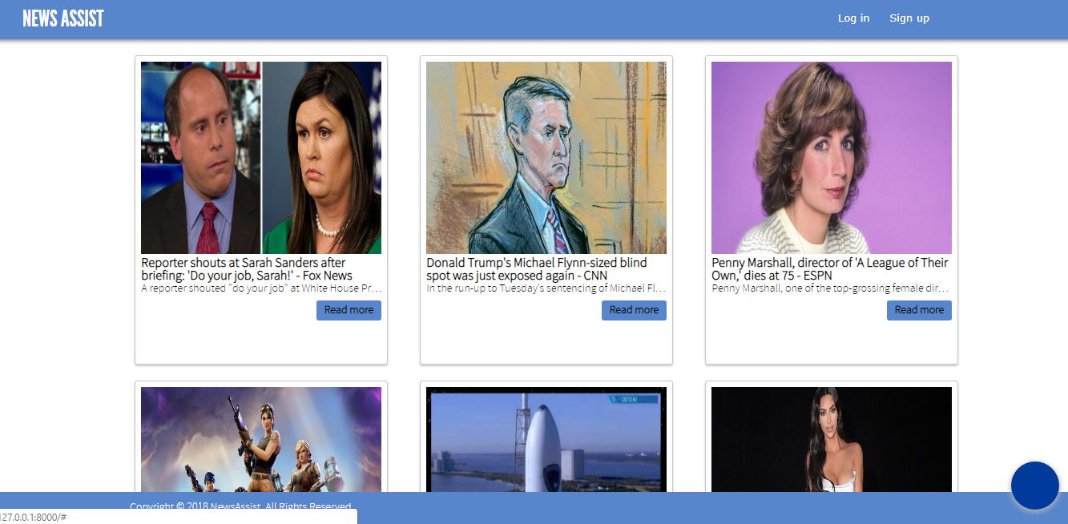

## 3.2 Sign Up

If the user wants to view different categories of news then he must register with us by filling in the basic details.

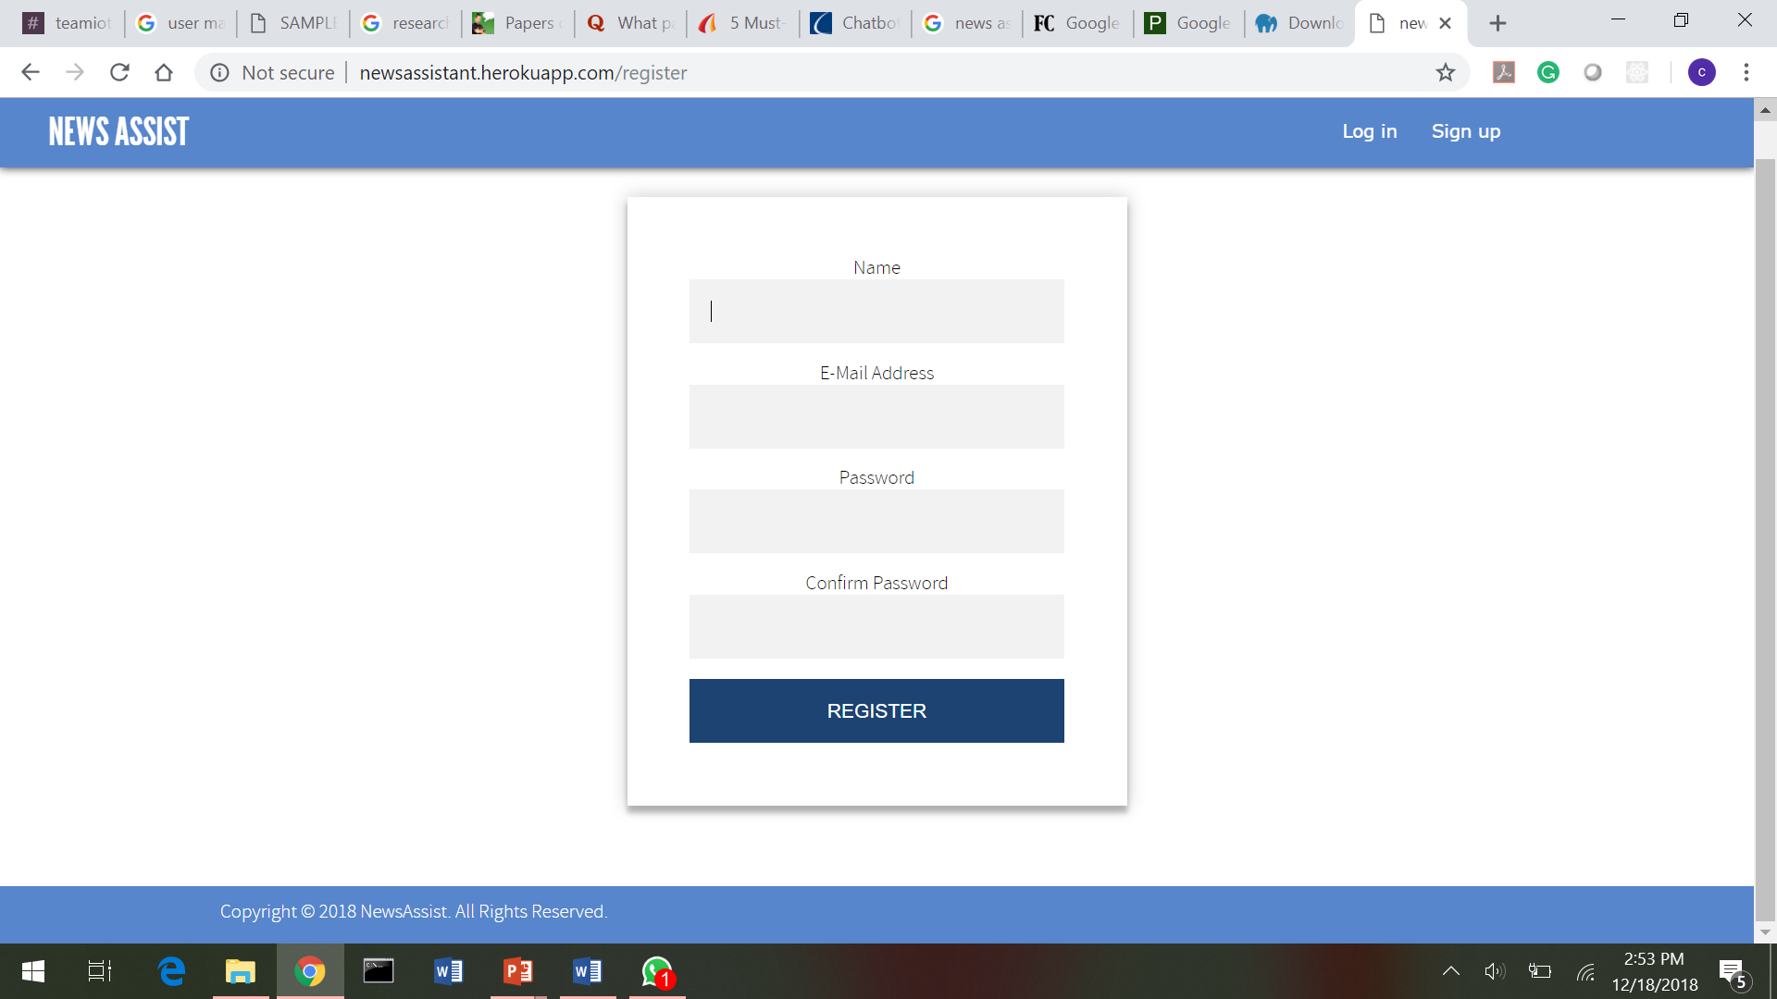

## 3.3 Log In

Returning users can just login by entering their credentials by entering the E-mail Address and Password used at the time of creating an account.

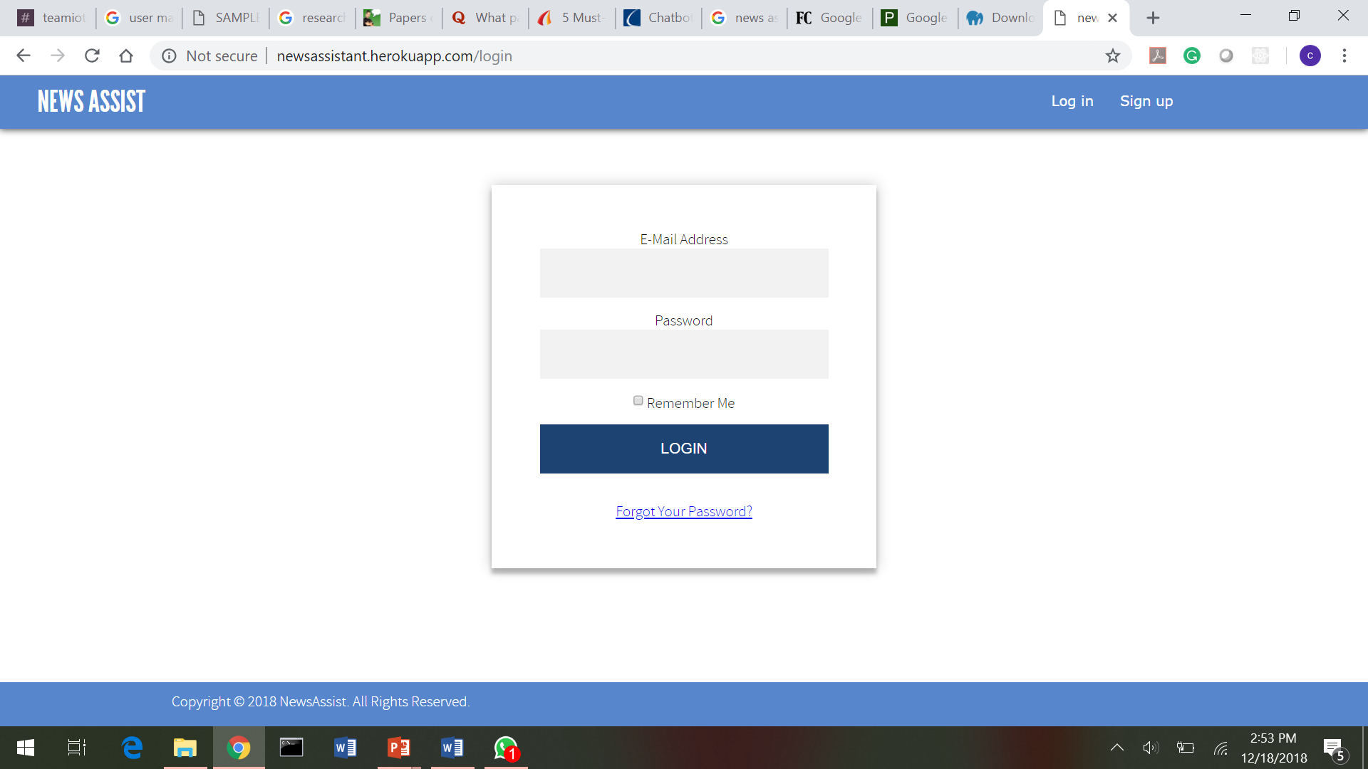

### 3.3.1 Save Password

Users can also save their details for future access

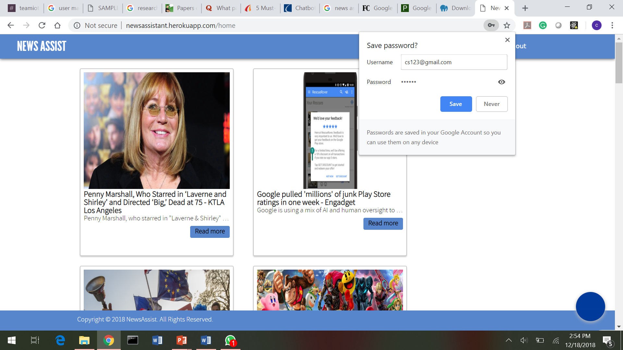

### 3.3.2 Forgot your Password

Enter the E-mail Address linked with account to reset your password

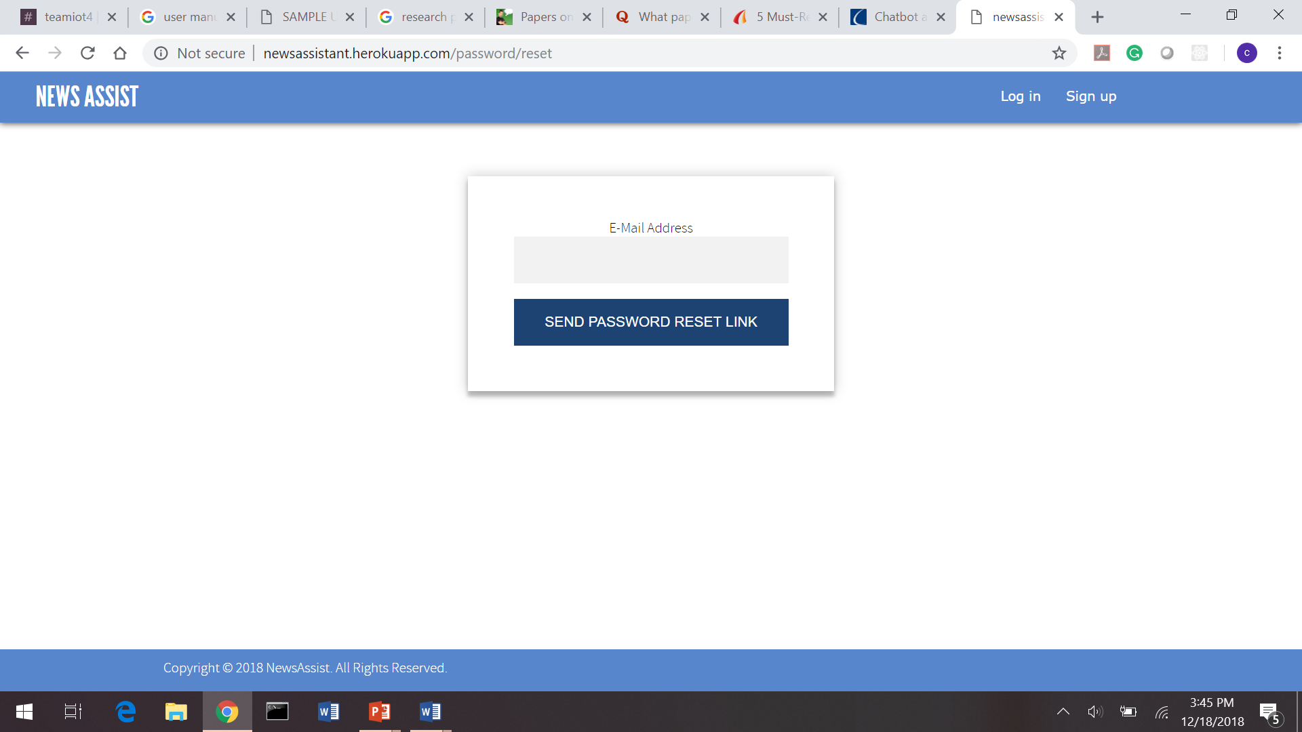

## 3.4 **Landing Page**

Once the user is Signed In, he can view news from different sections all over the world.

1. Chatbot on the bottom right side is one of the ways to get access to a specific news While, chatbot will guide through further steps.
2. Top right of navigation bar will display the Home, Categories and Logout links.

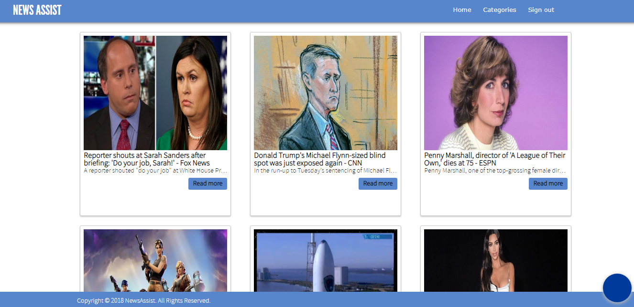

## 3.5 Categories

We have displayed few basic categories like Sports, Technology, Fashion and Entertainment

### 3.5.1 Sports

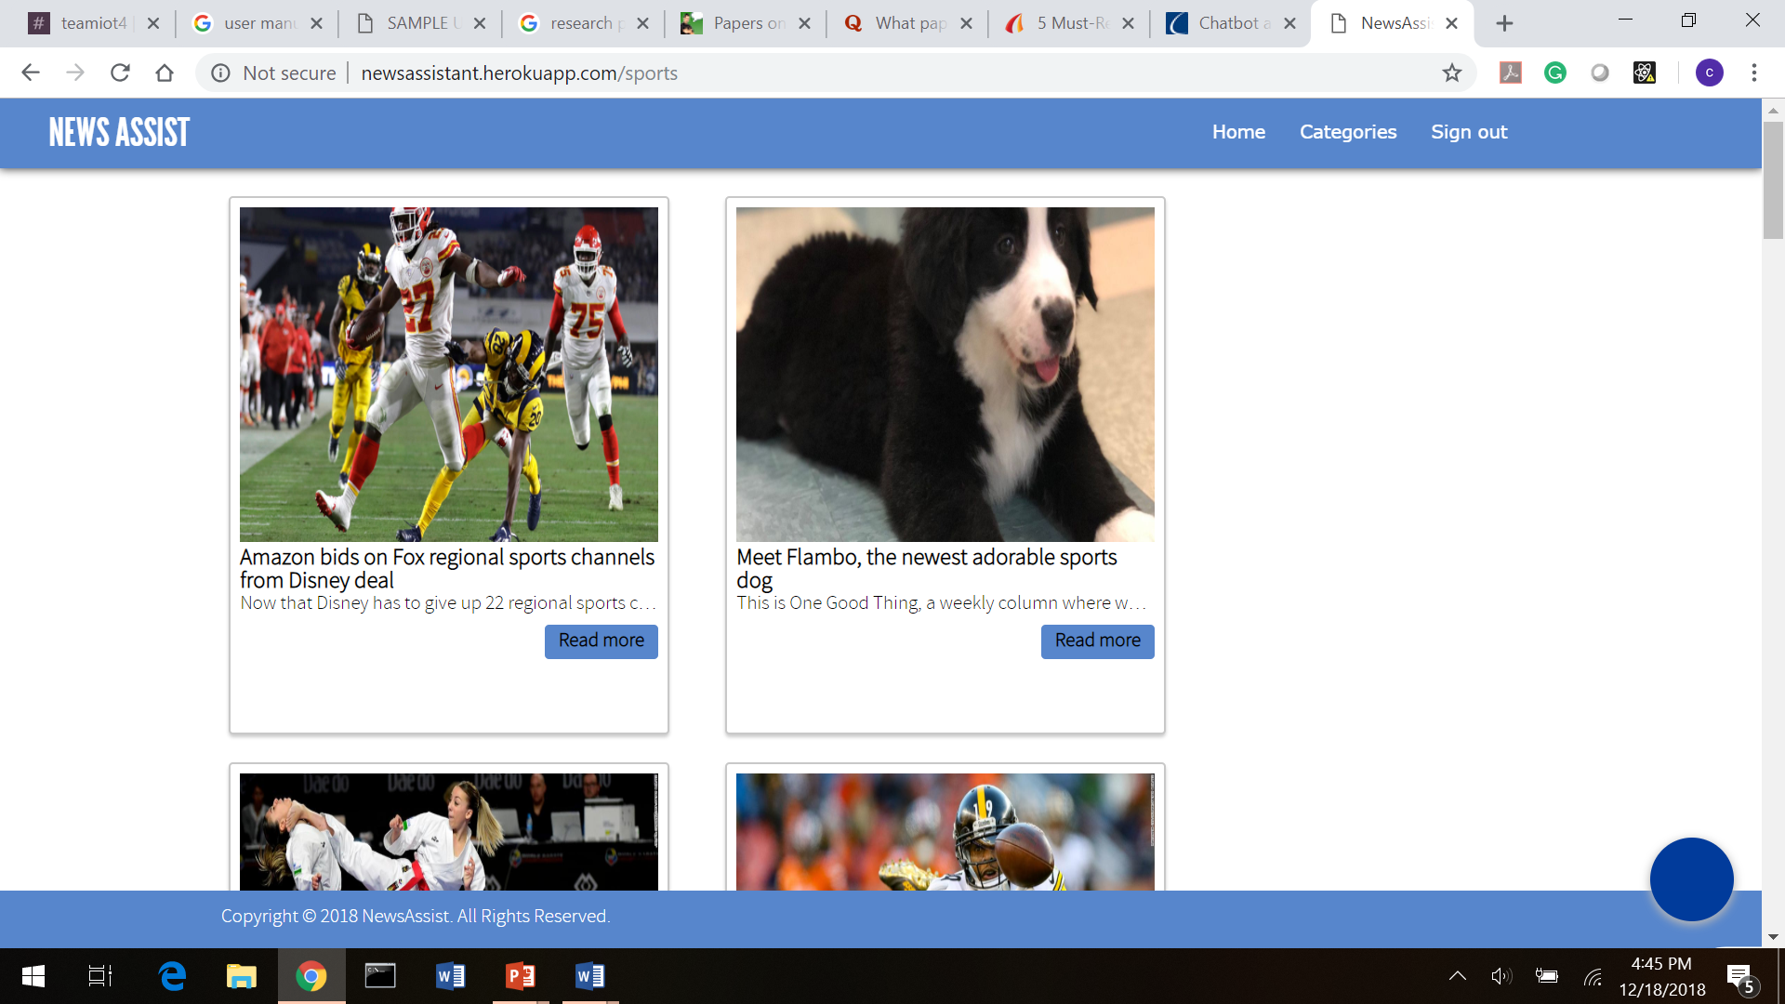

### 3.5.2 Entertainment

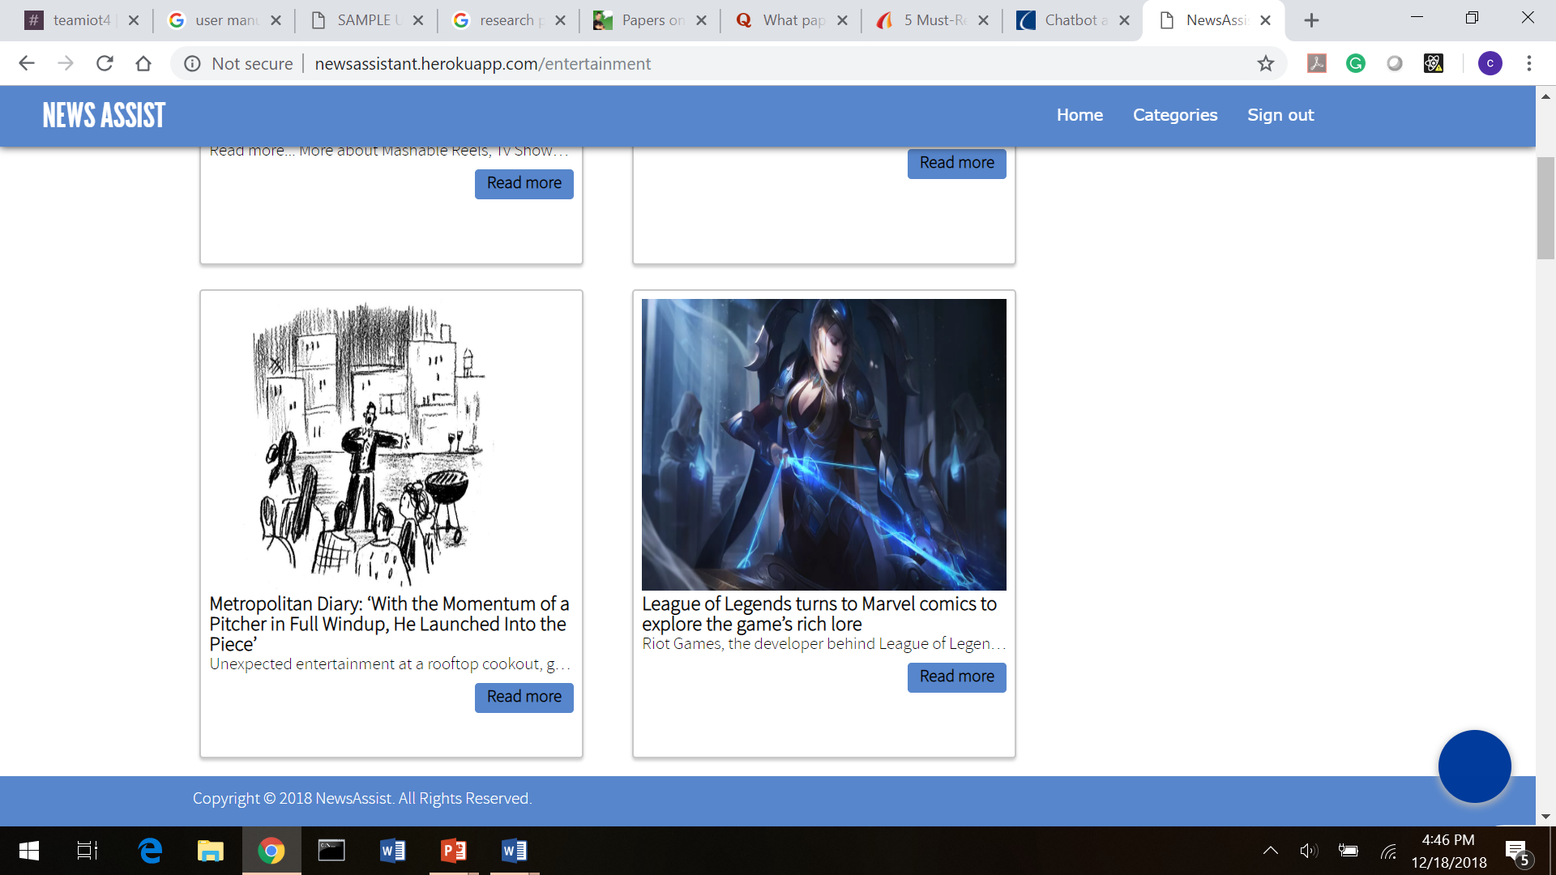

### 3.5.3 Technology

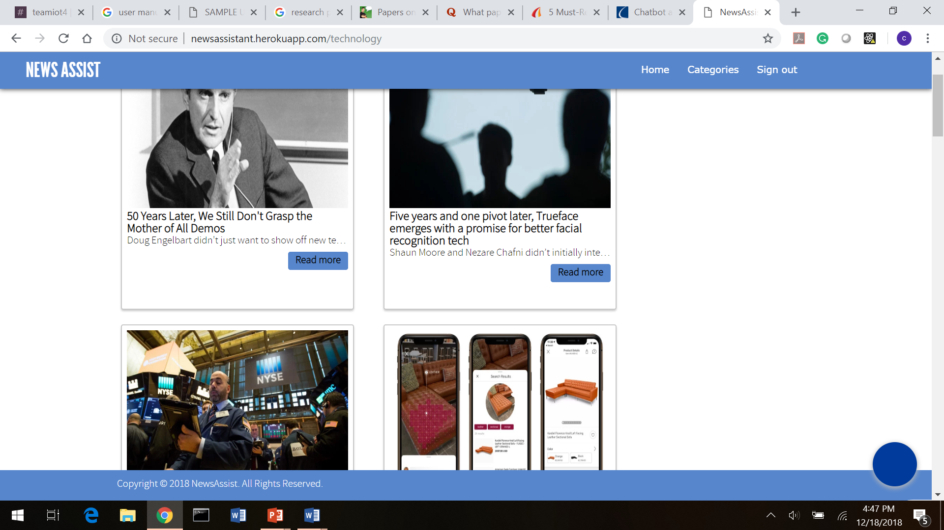

### 3.5.4 Fashion

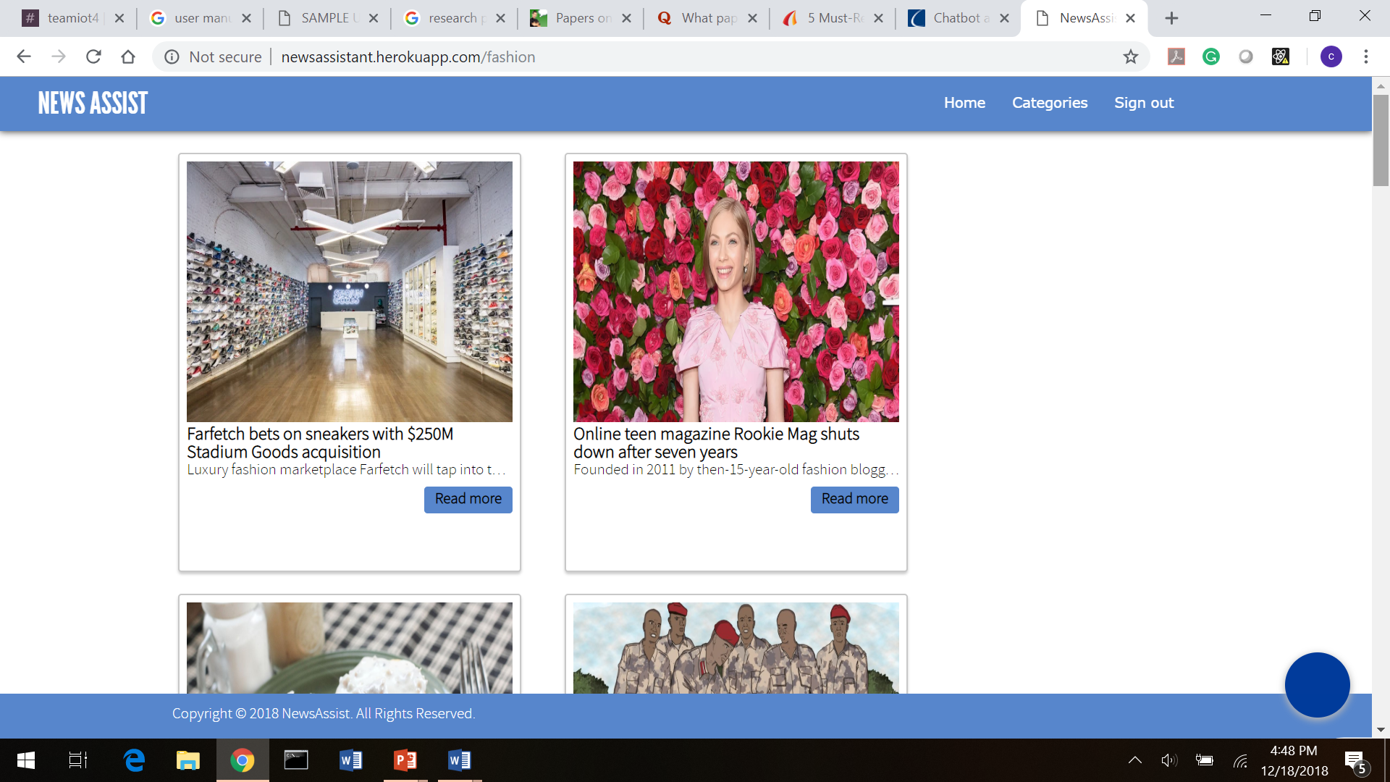

## 3.6 Detailed News Article View

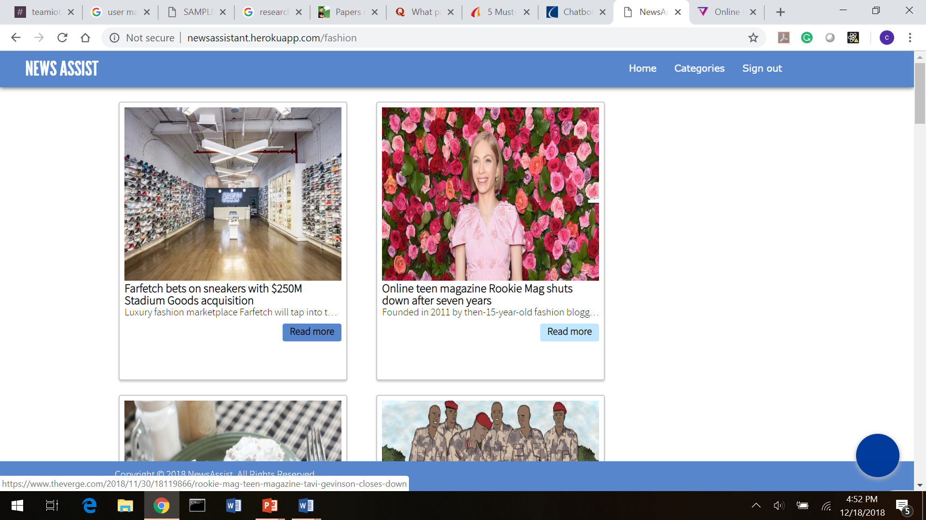

User can read the entire article by clicking on the “Read more” button at the bottom, after which the user will be redirected to the original link of the news article shown below:

